TestRail Admin Install And Setting

**Robinson Meng**

TestRail helps you manage and track your software testing efforts and organize your QA department. Its intuitive web-based user interface makes it easy to create test cases, manage test runs and coordinate your entire testing process.

REVISION HISTORY

|  |  |  |
| --- | --- | --- |
| REVISION | RELEASE DATE | COMMENTS |
| V1.0 | 09/21/2014 | Initial draft |

CONTENTS

1 Setup XAMPP 4

2 Install TestRail 4

3 Setup IonCube 4

4 Setup testRail in web 6

5 Setup Erlang 7

6 Install RabbitMQ 8

1. Setup XAMPP

1.1 Visit Website to get file

<https://www.apachefriends.org/xampp-files/5.6.15/xampp-linux-x64-5.6.15-1-installer.run>

1.2 chmod +x for this file and run it

1.3 Edit file of .cshrc and add path

setenv LD_LIBRARY_PATH

/opt/lampp/lib

set path= /opt/lampp/bin

Then you can type:

>> source .cshrc

>> sudo chmod +x ./xampp-linux-x64-5.6.15-1-installer.run

>> sudo ./xampp-linux-x64-5.6.15-1-installer.run

1.4 Edit /opt/lampp/etc/extra/httpd-xampp.conf and remove the comments of “Require local”

1.5 You can use “*sudo ./lamp start/stop*”to check work or not

1. Install TestRail
   1. Go to the website of TestRail and register, then you can get license and download address

<http://www.gurock.com/testrail/>

>> unzip testrail-5.1.0.3413-ion53.zip

>> sudo cp -r testrail /opt/lampp/htdocs/.

1. Setup ionCube
   1. Visit the website and download it

<http://www.ioncube.com/loaders.php>

<http://downloads3.ioncube.com/loader_downloads/ioncube_loaders_lin_x86-64.tar.gz>

3.2 Unzip to /opt/lamp/ioncube.

3.3 vi /opt/lampp/etc/php.ini

Search “zend_extension” and add the line

zend_extension=/opt/lampp/ioncube/ioncube_loader_lin_5.6.so

3.4 type “cd /opt/lamp” and “php –v”

It will shows,

PHP 5.6.15 (cli) (built: Dec 4 2015 22:22:44)

Copyright (c) 1997-2015 The PHP Group

with the ionCube PHP Loader (enabled) + Intrusion Protection from ioncube24.com (unconfigured) v5.0.19, Copyright (c) 2002-2015, by ionCube Ltd.

3.5 Restart the lampp

sudo ./lampp stop/start

3.6 Edit the password and permission

mysql -u root -p

Enter password: [Enter]

Welcome to the MariaDB monitor. Commands end with ; or \g.

Your MariaDB connection id is 13

Server version: 10.1.9-MariaDB Source distribution

Copyright (c) 2000, 2015, Oracle, MariaDB Corporation Ab and others.

Type 'help;' or '\h' for help. Type '\c' to clear the current input statement.

MariaDB [(none)]> set password for 'root'@'localhost'=PASSWORD('lattice');

3.7 vi phpmyadmin/config.inc.php and confirm it is not comments with item3

# $cfg['Servers'][$i]['auth_type'] = 'config'; #

# $cfg['Servers'][$i]['auth_type'] = 'http'; #

$cfg['Servers'][$i]['auth_type'] = 'cookie'; #

3.8 restart XAMPP

sudo ./lampp stop/start

1. Setup the testRail in web site

4.1 $ mysql -u root -p

> CREATE DATABASE testrail DEFAULT CHARACTER SET utf8 COLLATE utf8_unicode_ci;

> CREATE USER 'testrail'@'localhost' IDENTIFIED BY 'newpassword';

> GRANT ALL ON testrail.* TO 'testrail'@'localhost';

> CREATE USER 'testrail'@'::1' IDENTIFIED BY 'newpassword';

> GRANT ALL ON testrail.* TO 'testrail'@'::1';

> CREATE USER 'testrail'@'127.0.0.1' IDENTIFIED BY 'newpassword';

> GRANT ALL ON testrail.* TO 'testrail'@'127.0.0.1';

> CREATE USER 'testrail'@'linux16v.latticesemi.com' IDENTIFIED BY 'newpassword';

> GRANT ALL ON testrail.* TO 'testrail'@'linux16v.latticesemi.com';

> FLUSH PRIVILEGES;

4.2 Create the folds as following(attachmenr,logs,report)) and change permission to 775

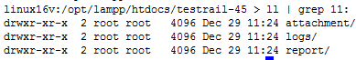

4.3 Type the http://<linux name>/testrail/index.php

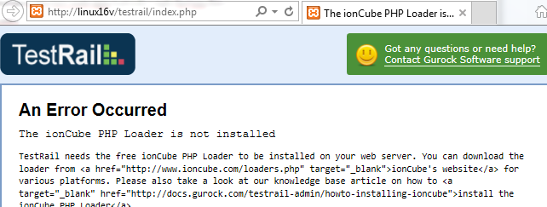

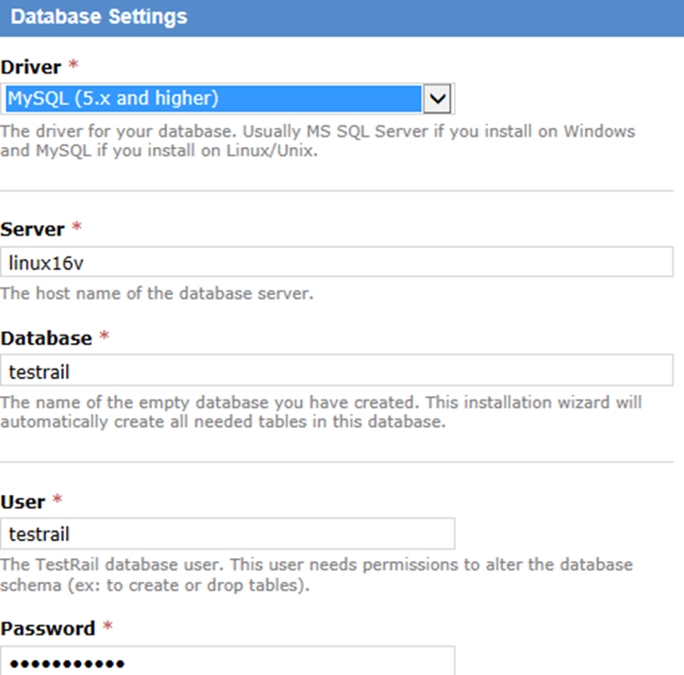

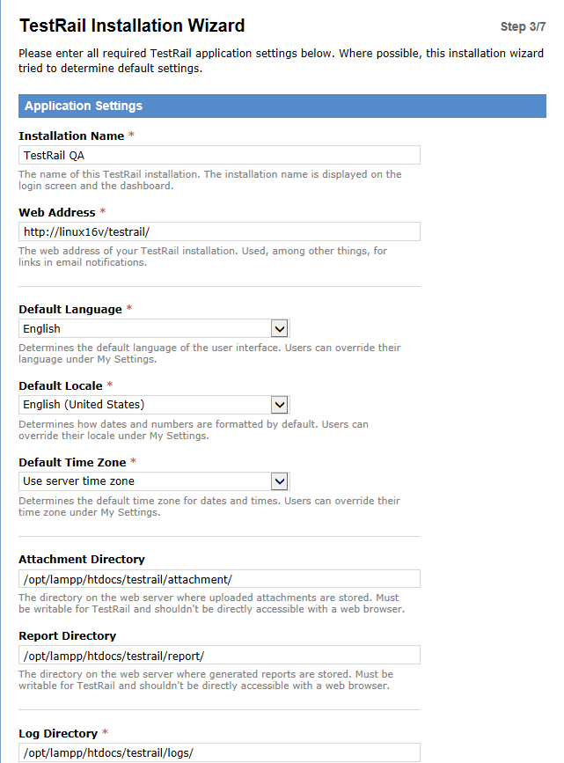

4.4 Save this file to:

/opt/lampp/htdocs/testrail/config.php

1. setup Erlang

5.1 Go to website and download

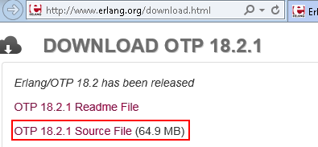

5.2 Install the sw

> ./configure

> make

> sudo make install

> source .cshrc

1. Install RabbitMQ

6.1 Go to website and download

<https://www.rabbitmq.com/download.html>

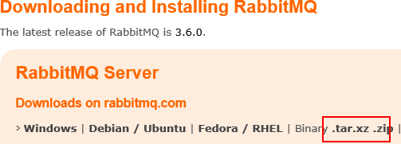

<https://www.rabbitmq.com/releases/rabbitmq-server/v3.5.6/>

6.2 Unzip and chmod –R 777 /opt/lamp/servers

./rabbitmq-server &

./rabbitmqctl add_user root root

6.3 Do following action

<1> linux11v:/home/syan/today1113/rabbitmq_server-3.5.6/sbin-103 > rabbitmqctl set_permissions -p / root ".*" ".*" ".*"

<2> linux11v:/home/syan/today1113/rabbitmq_server-3.5.6/sbin-104 > rabbitmqctl set_user_tags ad administrator

<3> linux11v:/home/syan/today1113/rabbitmq_server-3.5.6/sbin-105 > rabbitmqctl set_user_tags root administrator

<4> linux11v:/home/syan/today1113/rabbitmq_server-3.5.6/sbin-106 > rabbitmqctl list_users